**GULD BROWSER INSTALLATION:**

Guld Browser requires the following software:

* NPM – Node package manager
* Node - (version 5 or greater)
* ledger-cli - (version 3 or greater)
* pgp - (version 2.1 or greater) only required if there are no gpg keys

**Windows Installation**

1. See if you already have NPM installed (you need version 5 or greater):  
   open the Windows Command Prompt and type:   
   **npm –v**   
   (If installed you will see something similar to 5.0.3
2. See if you already have Node installed:  
   open the Windows Command Prompt and type:

**node –v**   
(If installed you will see something similar to v6.10.0

1. Node/NPM are installed together. If you do not have it installed follow these instructions:

* Go to the nodejs website: <https://nodejs.org/en/>
* Download the Windows installer from the **[Nodes.js® web site](http://nodejs.org/" \t "_blank).**
* Run the installer (the .msi file you downloaded in the previous step.)
* Follow the prompts in the installer (Accept the license agreement, click the NEXT button a bunch of times and accept the default installation settings  
    
  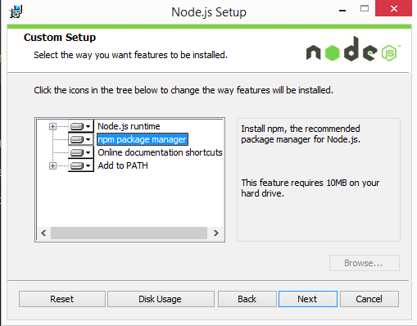
* **Restart your computer.** You won’t be able to run Node.js® until you restart your computer.
* Re-run steps 1 and 2 to confirm that you have installed Node and NPM

1. From the Windows Command Prompt Install ledger-cli. Type:  
   **npm install ledger-cli -g**
2. From the Windows Command Prompt Install gpg. Type:  
   **npm install gpg -g**

**Mac Installation**

1. See if you already have NPM installed:  
   open Terminal Promp and type:

**npm –v**   
(If installed you will see something similar to 5.0.3

1. See if you already have Node installed:  
   open Terminal Prompt and type:

**node –v**   
(If installed you will see something similar to v6.10.0

1. Node/NPM are installed together. If you do not have it installed follow these instructions:
   * Node requires 2 other applications before installation:
     + XCode (used for development on a Mac).  XCode is free and you can find it in the [Apple App Store](https://itunes.apple.com/us/app/xcode/id497799835?mt=12).
     + Homebrew (package manager for the Mac).
       - open Terminal Prompt
       - type: ruby -e "$(curl -fsSL https://raw.githubusercontent.com/Homebrew/install/master/install)"
   * Install Node/NPM:
     + open Terminal Prompt
     + type: brew install node
     + Re-run steps 1 and 2 to confirm that you have installed Node and NPM
2. From the Terminal Prompt Install ledger-cli. Type:  
   **npm install ledger-cli -g**
3. From the Terminal Prompt Install gpg. Type:  
   **npm install gpg -g**